Student ID 2022280000

Harbin Engineering University

Undergraduate Students Individual Project Report

Study on the wave parameter reconstruction based on machine-learning

College: Southampton Ocean Engineering Joint Institute Program Title: XXX Engineering
Student Name: San （名）Zhang（姓）

Supervisor: Wei MengAssociate Prof./Blair Thornton Prof.

Word count: 9188

Harbin Engineering University

May, 2026

学 号 2022280000

密 级 公开

哈尔滨工程大学本科生毕业论文

基于机器学习的波浪参数重构研究

学 院 名 称：南安普顿海洋工程联合学院

专 业 名 称：船舶与海洋工程

学 生 姓 名：张三

指 导 教 师：孟巍副教授/Blair Thornton 教授

哈尔滨工程大学

2026 年 5 月

书脊

Student ID: 202028XXXX

Study on the wave parameter reconstruction based on machine-learning

Student’s name

College

Program

Supervisor

Supervisor’s Title

University

Submission Date

Oral Defense Date

Degree award
：San Zhang

：Southampton Ocean Engineering Joint Institute

：**Engineering

：Wei Meng /Blair Thornton

：Associate professor/Professor

：Harbin Engineering University

：May 2026

：May 2026

：Harbin Engineering University

学 号：202028XXXX

密 级： 公开

基于机器学习的波浪参数重构研究

Preparation and study of XXXXX（IPTitle

）

学 生 姓 名 ：张三

所 在 学 院 ：南安普顿海洋工程联合学院 所 在 专 业 ：船舶与海洋工程
指 导 教 师 ：孟巍/Blair Thornton 职 称 ：副教授/教授
所 在 单 位 ：哈尔滨工程大学 论文提交日期 ：2026 年 5 月 论文答辩日期 ：2026 年 5 月 学位授予单位 ：哈尔滨工程大学

哈尔滨工程大学

学位论文原创性声明

本人郑重声明：本论文的所有工作，是在导师的指导下，由作者本人独立完

成的。有关观点、方法、数据和文献的引用已在文中指出，并与参考文献相对应。

除文中已注明引用的内容外，本论文不包含任何其他个人或集体已经公开发表的

作品成果。对本文的研究做出重要贡献的个人和集体，均已在文中以明确方式标

明。本人完全意识 到本声明的法律结果由本人承担。

作者（签字）：(电子签放上)

日期：2026 年 5 月 1 日

Harbin Engineering University

Declaration of Originality

I solemnly declare: All the work in this thesis was completed independently by me, the author, under the guidance of my supervisor. The references to the viewpoints, methods, data, and literature in this thesis have been indicated in the text and correspond to the Works Cited. Except for the content cited in the text, this thesis does not contain any other individual or collective work that has been published. Individuals and organisations who have made significant contributions to this study have been clearly indicated. I am fully aware of the legal consequences of this declaration and bear all responsibilities.

Author (Signature):(电子签放上)

Date: 2026/5/1

哈尔滨工程大学

学位论文原创性声明

本人完全了解学校保护知识产权的有关规定，即在校攻读学位期间论文工作的

知识产权属于哈尔滨工程大学。哈尔滨工程大学有权保留并向国家有关部门或机构

送交论文的复印件。本人允许哈尔滨工程大学将论文的部分或全部内容编入有关数

据库进行检索，可采用影印、缩印或扫描等复制手段保存和汇编本学位论文，可以

公布论文的全部内容。同时本人保证毕业后结合学位论文研究课题再撰写的论文一

律注明作者第一署名单位为哈尔滨工程大学。涉密学位论文待解密后适用本声明。

本论文（□在授予学位后即可 □在授予学位 12 个月后 □解密后）由哈尔滨工

程大学送交有关部门进行保存、汇编等。

作者（签字）：(电子签放上)

日期：2026年5月1 日
导师（签字）：(电子签放上)

2026年5月1日

Harbin Engineering University

ThesisAuthorization Statement

I fully understand the regulations of the university regarding the protection of

intellectual property rights, that is, the intellectual property rights of the thesis work during the period of pursuing a degree at the university belong to Harbin Engineering University. Harbin Engineering University has the right to retain and submit copies of the thesis to relevant national departments or institutions. I allow Harbin Engineering University to include part or all of the content of the thesis in relevant databases for retrieval, and to use photocopying, microfilming, scanning, or other means of reproduction to preserve and compile this thesis. The full content of the thesis can be made available to the public. At the same time, I guarantee that any papers written after graduation based on the research topic of this degree thesis will indicate that the author's first affiliation is Harbin Engineering University. This statement is applicable to confidential theses after they are declassified.
This thesis can be submitted to relevant departments for preservation and compilation by Harbin Engineering University (□ immediately after the degree is granted □ 12 months after the degree is granted □ after declassification).

Author (Signature):(电子签放上) Supervisor (Signature):(电子签放)

Date: 2026.5.1 Date:2026.5.1

9

ABSTRACT

The study of wave propagation characteristics near the ocean bottom is a prominent field

in oceanography.

The thesis XXX.

Keywords: Water wave; Ground wave; ship collision

I

摘 要

海洋声传播研究长期以来一直是海洋声学学科中的热门领域，尤其是在海底附近的 水波和地波传播特性方面，如时域波形和传播损失等。尽管目前在此领域取得了一定进 展，但对于水波和地波的分离研究甚少。这些问题的解决不仅对海洋声场分析有重要意 义，还对海洋资源开发和海底地震灾害预测具有实用价值。
在这一背景下，本文探讨了XXXX。 结果表明，XXXX。

关键词：水波；底波；模态频散；谱元法；水波分离

II

Contents（自动生成）

ABSTRACT...............................................................................................................................I

摘 要.......................................................................................................................................II

I Introduction............................................................................................................................1

1.1 Background and significance....................................................................................... 1

1.2 Ground waves and water waves...................................................................................1

1.3 Project aim and objectives............................................................................................2

1.3.1 Project aim.........................................................................................................2

1.3.2 Project objectives.............................................................................................. 2

1.4 Research contents.........................................................................................................2

II Literature Review.................................................................................................................3

2.1 Review of water wave and ground wave......................................................................3

2.2 Review of Spectral Element Method............................................................................3

III Brief Theory and Model.....................................................................................................4

3.1 Normal mode theory.....................................................................................................4

3.2 Ground/water waves and Airy waves theory............................................................... 4

3.3 Spectral Element Method Model based on SPECFEM2D...........................................5

3.3.1 SPECFEM2D program configuration...............................................................5

3.3.2 Simulation environment establishment.............................................................5

3.4 Chapter Summary.........................................................................................................6

IV Numerical study of Ground/ Water waves.......................................................................7

4.1 Numerical methods and parameter settings..................................................................7

4.2 Separation of ground and water waves.........................................................................7

4.2.1 Time-domain characteristics analysis............................................................... 8

4.2.2 τ-p transformation analysis................................................................................8

4.2.3 Ground/water wave separation........................................错误！未定义书签。

4.3 Transmission Loss Analysis.........................................................................................8

4.4 Chapter summary......................................................................................................... 8

V Shallow water experiment analysis.....................................................................................9

III

5.1 Experiment Overview...................................................................................................9

5.2 Data Processing and Analysis...................................................................................... 9

5.3 Chapter Summary.........................................................................................................9

VI Conclusion......................................................................................................................... 10

Reference.................................................................................................................................11

致谢..........................................................................................................................................12

Acknowledgement.................................................................................................................. 13

Published papers and research achievements during the pursuit of bachelor's degree..14

Appendix................................................................................................................................. 15

IV
Introduction

I Introduction

1.1 Background and significance

Oceans cover more than seventy percent of theEarth's surface, serving as the cradle of life,

nurturing countless species and abundant energy resources.

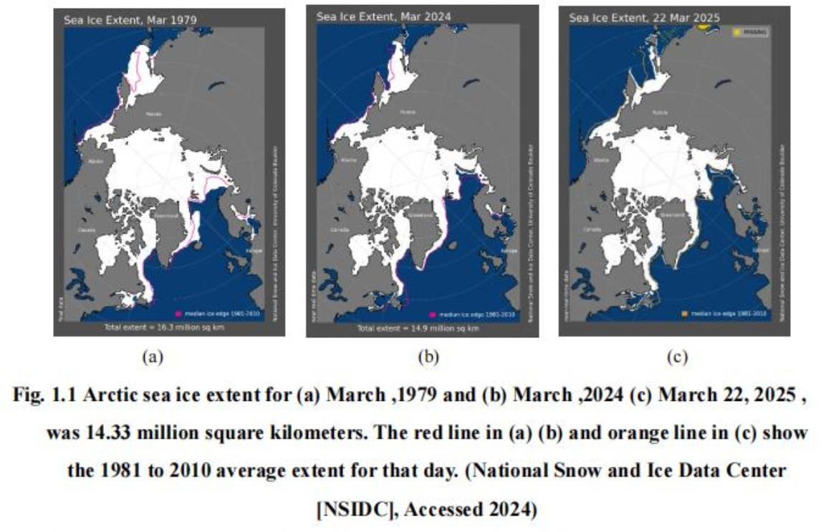
（图片和表格注释参考南安普顿书写要求，查找路径：钉钉全院文件夹——22级毕 设——IP 辅导PPT资料——2022级IP 辅导资料）

1.2 Ground waves and water waves

In shallow water environments, the propagation of sound waves is determined by the

unique physical properties of the environment, exhibiting distinct propagation characteristics

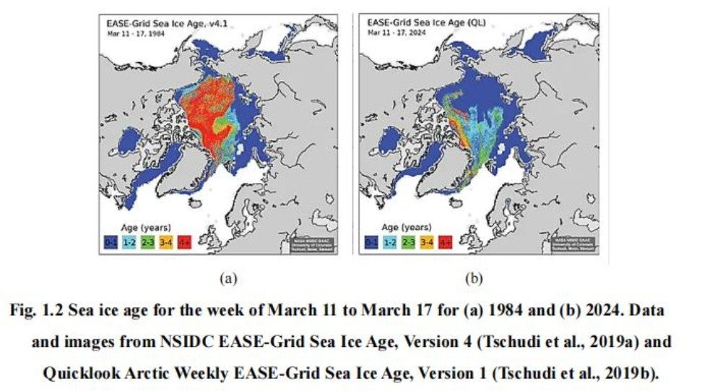
(Pekeris 17).
哈尔滨工程大学学士学位论文

1.3 Project aim and objectives

1.3.1 Project aim

The project focuses on the acoustic propagation characteristics of broadband sound

sources in shallow water, aiming to study theoretically and experimentally the method of

separating the ground wave from water wave and analyse the transmission efficiency.

1.3.2 Project objectives

To comprehensively understand and simulate the interaction between ground and water

waves, the research has established the following specific objectives:

1.4 Research contents

This thesis analyses water and ground waves near the ocean bottom from numerical

simulation and experimental data processing perspectives.

2
Literature Review

II Literature Review

2.1 Review of water wave and ground wave

As early as 1948, Pekeris proposed a method for solving the normal mode acoustic field

in the context of exploring shallow water waveguide problems composed of a uniform fluid

layer and a semi-infinite liquid ocean bottom layer (Pekeris 43).

2.2 Review of Spectral Element Method

The spectral element method, as a type of generalised finite element method, combines

the flexible handling capability of the finite element method with the high-speed convergence

characteristics of the pseudo-spectral method, providing an efficient solution for the

numerical simulation of sound wave propagation (TANG 65–75).

3
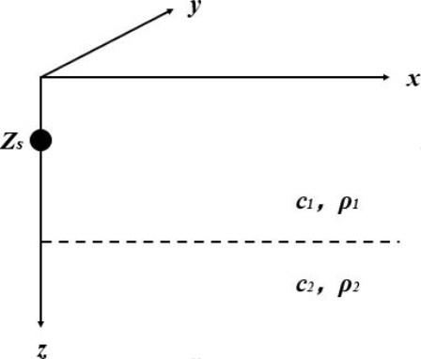
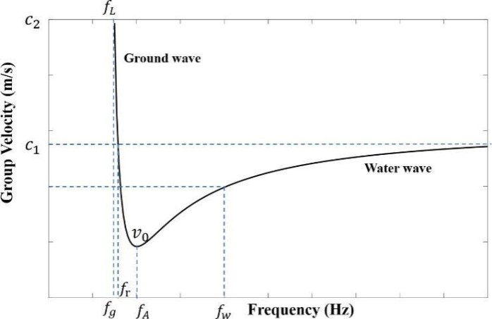
哈尔滨工程大学学士学位论文

III Brief Theory and Model

In studying sound propagation in shallow waters, broadband point sources are taken into

consideration.

3.1 Normal mode theory

The normal mode theory was first developed by Pekeris as a simple two-layer fluid

ocean model (Jensen et al. 102–33).

3.2 Ground/water waves and Airy waves theory

The Pekeris waveguide, proposed by Pekeris, is a waveguide environment consisting of

a uniform seawater layer and a liquid semi-infinite space beneath it (Pekeris 1–116)

Fig. 3.2 Pekeris waveguide environment

Fig. 3.3 First-Order Mode Group Velocity-Frequency Relationship

4
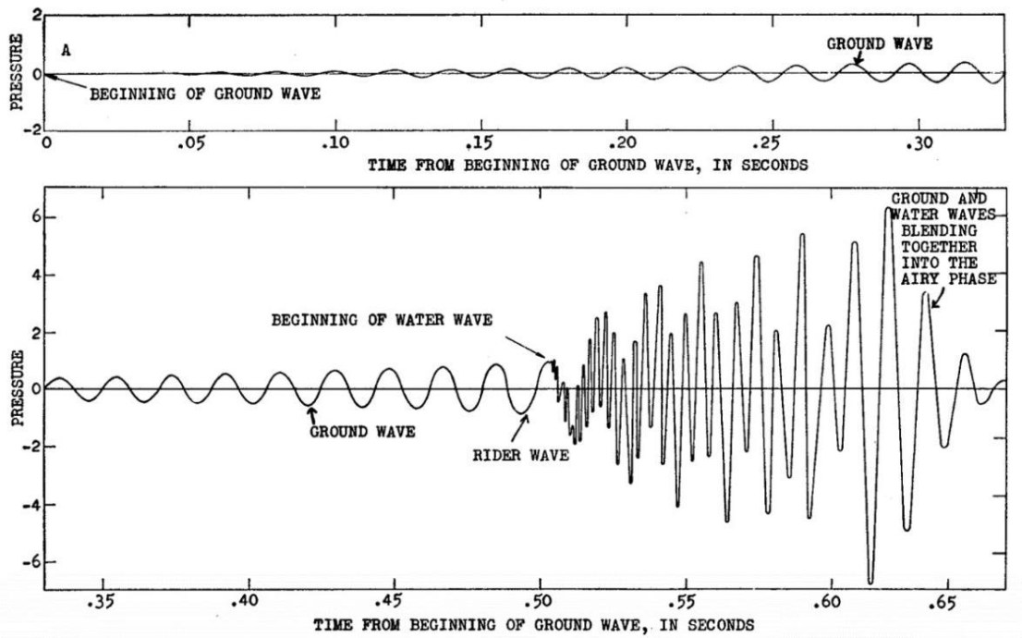
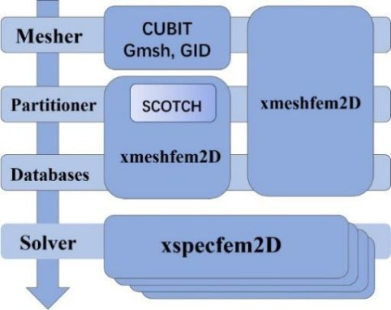
Brief Theory and Model

Fig. 3.4 Theoretical contribution of the first mode to the disturbance, from Chaim Leib

Pekeris, "Theory of Propagation of Explosive Sound in Shallow Water" (1948 94).

3.3 Spectral Element Method Model based on SPECFEM2D

The core idea of the Spectral Element Method is to first divide the entire computational

area into a finite number of elements and then apply the Pseudospectral Method, distributing

non-uniform nodes within each element.

3.3.1 SPECFEM2D program configuration

SPECFEM2D is a Spectral Element Method program designed for computations on

Linux systems.

Fig. 3.5 SPECFEM2D Simulation Flowchart

3.3.2 Simulation environment establishment

5
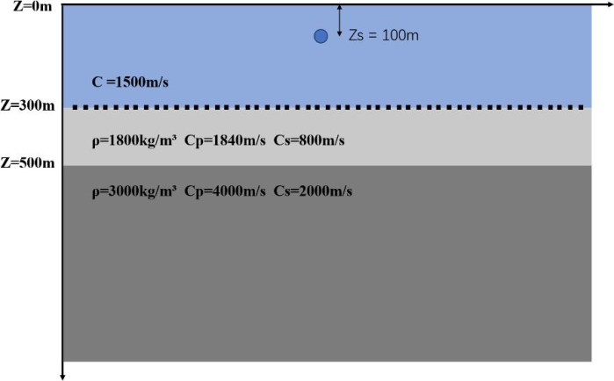
哈尔滨工程大学学士学位论文

When conducting ocean acoustic field modelling, it is necessary to determine parameters

suchassoundspeedanddensity.

Fig. 3.6 Shallow water wave guide model

3.4 Chapter Summary

This chapter primarily conducts theoretical analyses on the following three aspects:

6
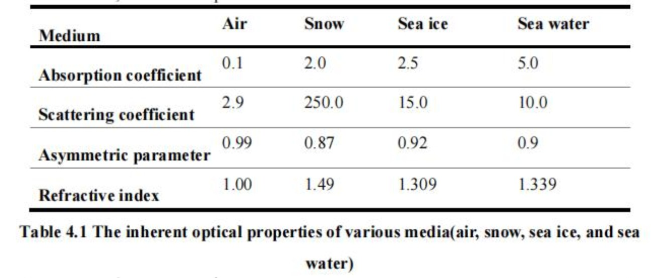
Numerical study of Ground/ Water waves

IV Numerical study of Ground/ Water waves

In order to measure the transmission efficiency of the water wave-ground wave channel,

the study utilises the water layer, elastic sedimentary layer, and semi-infinite ocean bottom

layer model created in Section 3.3 using the spectral element method.

4.1 Numerical methods and parameter settings

The separation of water waves from ground waves first necessitates the modal resolution

of water and ground wave signals, achieved through domain transformation of signals

received by the horizontal array stations.

7
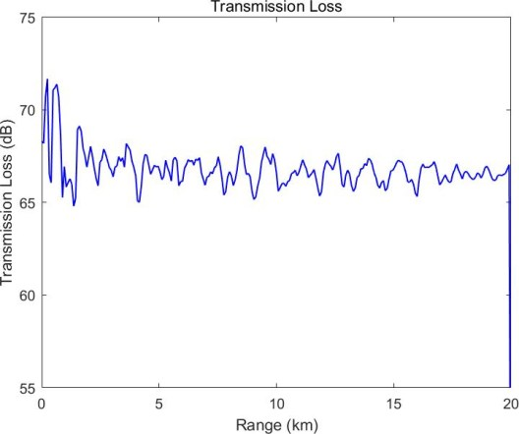
哈尔滨工程大学学士学位论文

4.2 Separation of ground and water waves

4.2.1 Time-domain characteristics analysis

4.2.2 τ-p transformation analysis

The method of t - p transformation involves stacking signals in the xt- domain according

to different intercepts t and slopes p (Zhou and Greenhalgh 1133–49).

4.3 Transmission Loss Analysis

As shown in Fig. 4.12, sound waves exhibit significant attenuation characteristics near

the source area.

Fig. 4.12 Transmission Loss

4.4 Chapter summary

This chapter aims to improve the comprehension of how sound waves propagate in the

horizontallystratified waveguides byutilising theSPECFEM2Dforsound field modelling.

8
Shallow water experiment analysis

V Shallow water experiment analysis

As shown in Chapter 4, it presents a simulation of a three-layer horizontally stratified

ocean bottom using the two-dimensional Spectral Element Method.

5.1 Experiment Overview

The College of Underwater Acoustic Engineering at Harbin Engineering University

conducted a comprehensive marine experiment in a specific sea area.

5.2 Data Processing and Analysis

Similar to numerical studies, the processing of experimental data primarily relies on the

water-ground modal separation technique based on the time-frequency characteristics of

signals from horizontal arrays at the ocean bottom interface.

5.3 Chapter Summary

This chapter focuses on the processing and analysis of experimental data, with the aim

of separating the ground waves and water waves.

9
哈尔滨工程大学学士学位论文

VI Conclusion

The aim of the study is to separate the ground waves and water waves in a horizontally

stratified environment.

10
Study of the ground wave and water wave near ocean bottom

Reference

参考文献写作规范参考哈佛大学写作规范（查找路径：钉钉全院文件夹——22级毕设 ——论文模板）

11
哈尔滨工程大学学士学位论文

致谢

12
Study of the ground wave and water wave near ocean bottom

Acknowledgement

13
哈尔滨工程大学学士学位论文

Published papers and research achievements during the pursuit of bachelor's degree

14
Study of the ground wave and water wave near ocean bottom

Appendix

15

